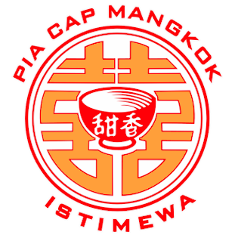
CV. MANGKOK MERAH FOOD
Jl. Semeru No. 25 Malang (0341) 335900
Ruko Grand Soekarno Hatta Kav 16-17 (0341) 2996400
Jl. Villa Tidar Indah No.5, Pisang Candi, Sukun (0341) 569283
Jalan Raya Randu Agung No.9, Randuangung, Singosari (0341) 458488

FORM RESELLER PIA CAP MANGKOK

Isilah data di bawah ini:
NAMA : ____________________________________________________
NO. TELP : ____________________________________________________
ALAMAT : ____________________________________________________
NAMA TOKO : ____________________________________________________
ALAMAT TOKO : ____________________________________________________
NPWP : ____________________________________________________
E-MAIL : ____________________________________________________

Apabila sudah mengisi form kami di atas, mohon mengirimkan email ke alamat berikut:
piamangkoksm@gmail.com
Dan kami akan menghubungi Anda kembali.
Terimakasih.

